**Task4**

**Project: OLAP Operations -**

**TASK 4: 1)**

CREATE DATABASE sales_data;

CREATE TABLE sales_sample (

Product_Id INT,

Region VARCHAR(50),

Date DATE,

Sales_Amount INT

);

**TASK 4: 2)**

INSERT INTO sales_sample (Product_Id, Region, Date, Sales_Amount) VALUES

(1, 'North', '2022-03-23', 15000),

(2, 'South', '2022-12-02', 21500),

(3, 'South', '2022-05-09', 32500),

(4, 'East', '2024-11-08', 42500),

(1, 'West', '2024-10-21', 11500),

(2, 'West', '2024-09-22', 26500),

(3, 'North', '2024-02-03', 35100),

(4, 'North', '2024-06-04', 48600),

(1, 'East', '2024-03-12', 95200),

(2, 'East', '2024-09-11', 92600);

Select * from sales_sample;

**TASK 4: 3a)**

SELECT Region, Product_Id, SUM(Sales_Amount) AS Sales_Sum

FROM sales_sample

GROUP BY Region, Product_Id

ORDER BY Region, Product_Id;

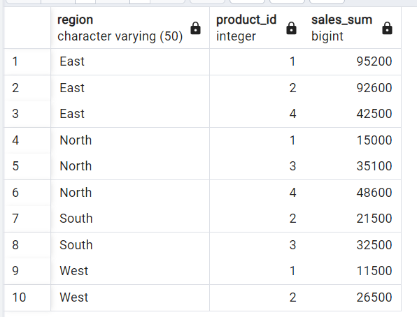

**TASK 4: 3b)**

SELECT Product_Id, Region, SUM(Sales_Amount) AS Sales_Sum

FROM sales_sample

GROUP BY ROLLUP (Product_Id, Region)

ORDER BY Product_Id, Region;

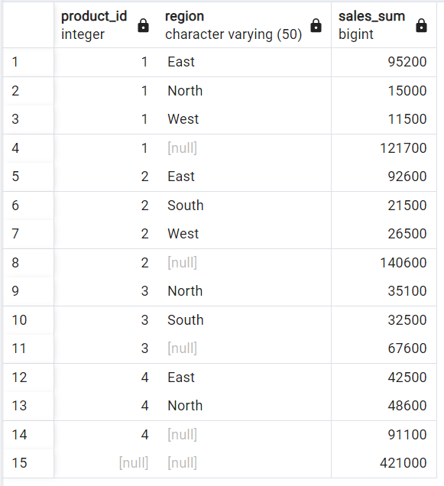

**TASK 4: 3c)**

SELECT Product_Id, Region, Date, SUM(Sales_Amount) AS Sales_Sum

FROM sales_sample

GROUP BY Cube (Product_Id, Region, Date)

ORDER BY Product_Id, Region, Date;

**TASK 4: 3d)**

SELECT Product_Id, Region, Date, Sales_Amount

FROM sales_sample

WHERE Region = 'West';

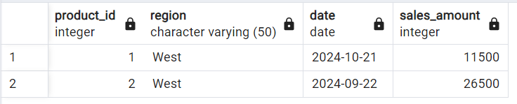

SELECT Product_Id, Region, Date, Sales_Amount

FROM sales_sample

WHERE Date BETWEEN '2022-05-09' AND '2024-03-12';

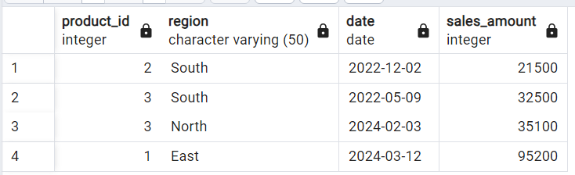

**TASK 4: 3e)**

SELECT Product_Id, Region, Date, Sales_Amount

FROM sales_sample

WHERE Product_Id = 1 AND Region = 'East' AND Date BETWEEN '2022-05-09' AND '2024-03-12';

